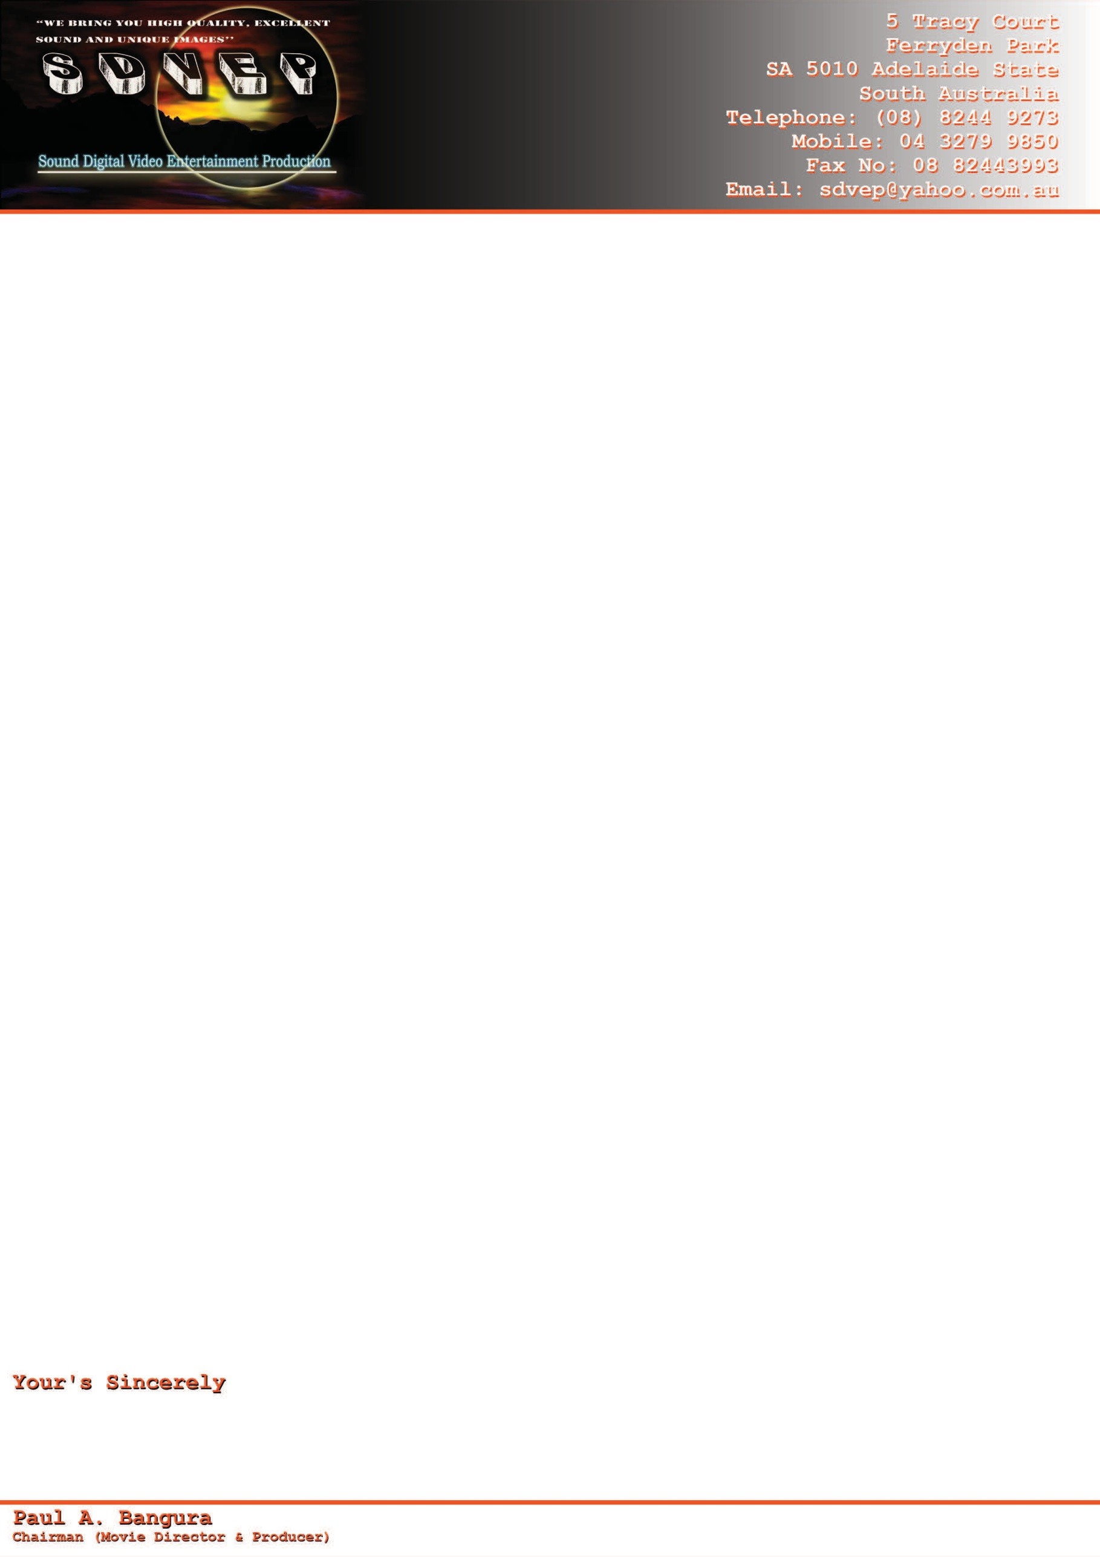

CREW CONSENT AND MEMBERSHIP FORM (SDVEP)

I------------------------------------------OF ---------------------------------------------------------- am willing to become a member, and to Participate in all activities of the Sound Digital Video Entertainment Production [SDVEP}

I am also committed to adhere to the rules and regulations of the Organization (SDVEP)

Signature of member Date Contact Number Date of Birth

------------------------------ --------/----------/------------ --------------------------------- ------/-------/--------